Content

1. Flow Chart of the application 1

2. Hot to run this project 1

2.1. Import the project 2

2.2. Run the launcher class 2

2.3. How to use the Quiz manager as a Teacher or as a Student 2

Select an option (1 or 2) 2

2.3.1. If you select 1 you are Logged in as a Teacher 2

2.3.2. If you select 2 to log in as a Student 2

# Flow Chart of the application

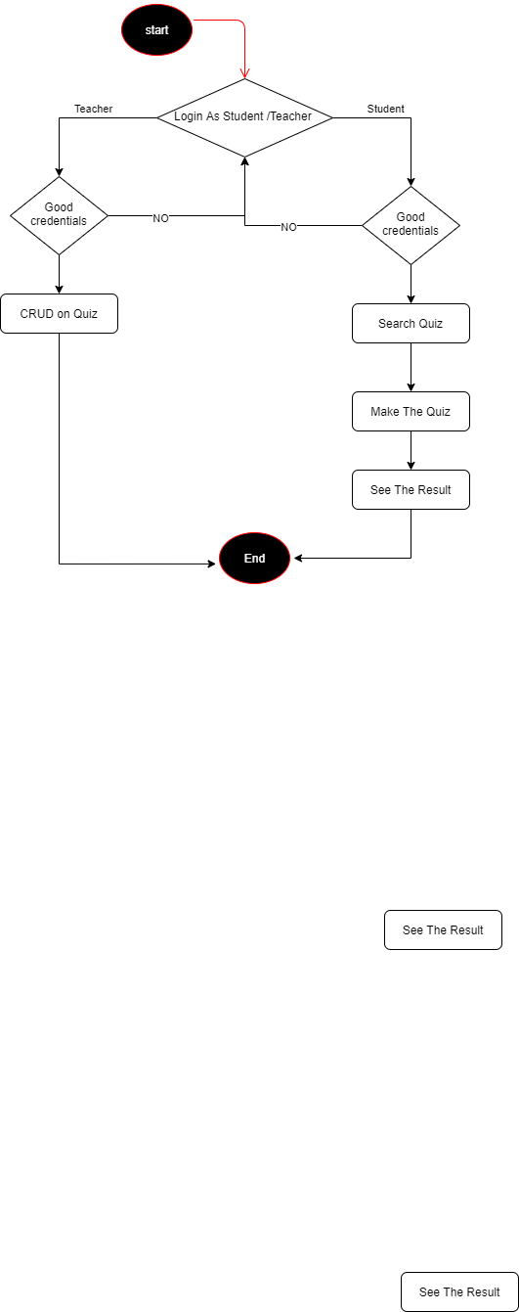

# Hot to run this project

The different steps and snapshot for the usage of the application are:

## Import the project

Import the project on the IDE.

## Run the launcher class

All the tables will be created automatically.

## How to use the Quiz manager as a Teacher or as a Student

## Select an option (1 or 2)

### If you select 1 you are Logged in as a Teacher

* Enter Credential of Teacher:
  + Username = Admin
  + Password = 1234
* Select an action
  + Create

After selecting this option, the teacher can create a question by:

* + - Setting up the topics
    - Setting up the difficulty
    - Then by Setting up the Subject
  + Research

After selection this option the teacher can search a question based on the topics of the question

* + Update

This option is to update one question in the database

* + Delete

This option is to delete a question in the database

* + Quit

The teacher selects this option to quit the CRUD

### If you select 2 to log in as a Student

* You must also enter credentials of Student
  + Username = Student
  + Password = 1234
* Select a question to answer base on the topics
* Select a question to answer base on the ID
* Write is answer
* See the result
* quit